**Questions for hands-on training session 2**

* **Task 1:**

Please write a command to create a simple table [table name ‘countries’] including columns of Country_id, country_name and region_id.

Country_id is an abbreviation of the country, like FI for Finland. Region_id is of a numeric type, like 358 for Finland. Please choose a proper data type for each column.

* **Task 2:**

Please insert a record to the table via clicking on HeidiSQL, other than writing a MySQL command.

* **Task 3:** [Not for Sequel Pro (MySQL GUI for Mac computer) user, because Sequel Pro seems to not support this function]

Please browse the “Report” window at the bottom of HeidiSQL after inserting a record to the table, copy the command from HeidiSQL from the “Report” window and paste the command to the “command” interface.

Insert a new record by changing the inserted values in the command.

* **Task 4:**

Please write a MySQL command to create a table ‘dup_countries’ that copies variables [or structure of variables] of the table ‘countries’. Note that the table ‘dup_countries’ should not contain any data.

* **Task 5:**

Please drop the table ‘dup_countries’

* **Task 6:**

Please write a MySQL command to create a table named as ‘dup_countries’ that copies both the variables and the data from the table ‘countries’.

* **Task 7:**

Please write a MySQL command to create a table ‘countries2’ including columns of country_code, country_name and region_id. All the columns should have a constraint of having no NULL value.

* **Task 8:**

Please write a MySQL command to create a table ‘countries3’ including columns of country_code, country_name and region_id.

For country_name, no countries except Finland, Sweden and Denmark can be entered in the table.

After that, please insert a record to the table and check whether you can only insert the values of these three countries only.

* **Task 9：**

Please write a MySQL command to create a simple table ‘memory’ including two columns of Happy_date and Happy_time. Happy_date has a date format and Happy_time has a time format. Happy_time allows null value.

* Insert a value of 20170112 for Happy_date and a value of 111111 for Happy_time.
* Insert a value of 20170113 for Happy_date and null value for Happy_time.
* Insert current date for Happy_date and current time for Happy_time.
* Insert current date and current time for multiple times and check the difference.
* **Task 10:**

Please export the data of table **orderdetails** to be a CSV file. The data in the CSV file should include the column names. After successfully exporting the data, please open the CSV file via excel.

Please check whether you successfully export all 2,996 rows of records from the table orderdetails.

* **Task 11:**

Please change settings when exporting data from MySQL, such as settings of null value, whether or not to include column names, or export the data to different types of files (e.g. Delimited text), and check the output files.

* **Advance tasks:**

Please first click to activate a table from the table list. After that, please click to activate the **table** **view** of the selected table (see figure below), then click “CREAT code”, you will find some useful information here.

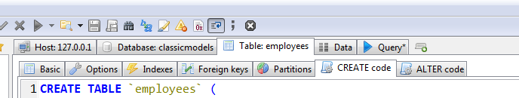

**Task 1: Create a table in the following format.**

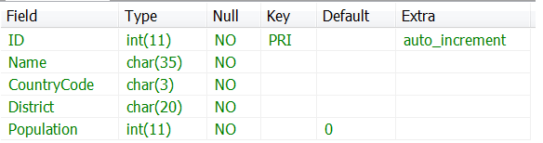

- Please insert a comment or annotation [“this is a table”] to this table via HeidiSQL’s own function.

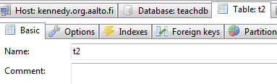

* **Task 2: Create a table in the following format**

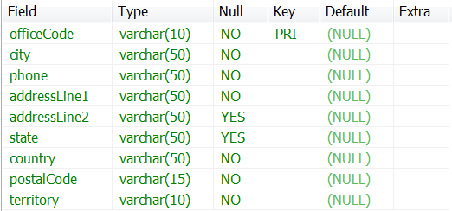

- Please insert a comment or annotation [‘this is another table’] to this table via HeidiSQL’s own function.

* **Task 3: Please try to create the above tables by clicking on HeidiSQL’s interface, instead of writing code.**